Supplementary material

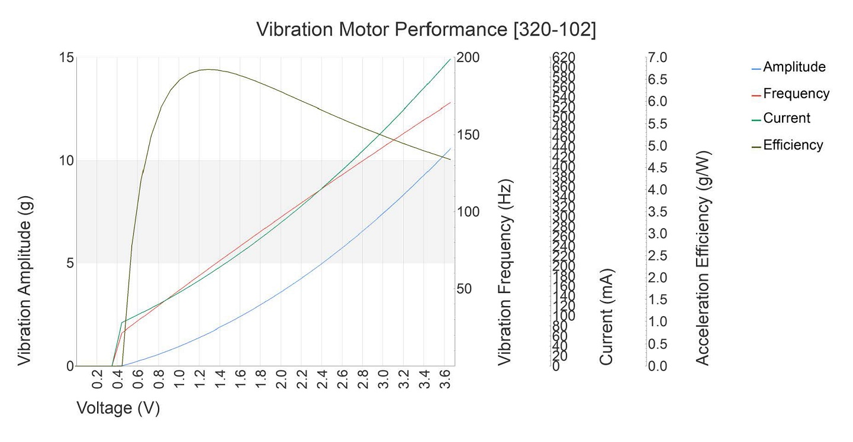

Supplementary Fig. 1. Vibration motor performance characteristics of the precision Microdrive 320–102.